Keshav Mahavidyalaya
University of Delhi
Department of Computer Science

Blockchain & It’s Application
Practical File
Paper Code : 2443010030

Submitted By
Nitish Thakur
Roll No: 22035570036 | Section: B
B.Sc (Hons.) Computer Science, Sem-VIII
Academic Year: 2025-26

Index

Contents
Index 2
Practical 1: Digital Signature – Signing & Verification 4
Question 4
Code 4
Compilation Command 5
Output 5
Practical 2: Blockchain Implementation with Transactions 6
Question 6
Code 6
Output 7
Practical 3: SHA-256 Hashing – Avalanche Effect 9
Question 9
Code 9
Output 10
Explanation – Avalanche Effect 10
Practical 4: SHA-256 Hash for 'Hello World' 11
Question 11
Code 11
Compilation Command 11
Output 11
Technical Verification 12
Practical 5: RSA Encryption & Decryption 12
Question 12
Step-by-Step Mathematical Calculation 12
Code 12
Output 13
Practical 6: Proof of Work Blockchain 14
Question 14
Code 14
Output 15
Practical 7: 5-Block Blockchain, Tamper Detection & Distributed Network 16
Q1 – Blockchain of 5 Blocks with SHA-256 Hash & Integrity Check 16
Q1 Output 17
Q2 – Tamper Block 3 and Detect Chain Validation Failure 17
Q2 Output 18
Q3 – 5-Node Distributed Network 18
Q3 Output 18
Practical 8: Solidity Smart Contract Implementation 19
Q1 – Basic Smart Contract Structure (Student Registry) 19
Q1 Output 20
Q3 – Fund Transfer Contract 20
Q3 Output 21
Practical 9: Hyperledger Fabric – Setup & Execution 22
Objective 22
Exercise 1: Network Initialization 22
Output – Active Containers 22
Exercise 2: Permissioned Ledger & Transaction Execution 23
Output – Ledger Query Result 23
Exercise 3: Cross-Organization Communication 24
Output 24
Key Learnings 24

Practical 1: Digital Signature – Signing & Verification

Date | 2025-26
Language | C++ (OpenSSL Library)
Algorithm | RSA-2048 with SHA-256

Question
Write a program to demonstrate sending a digitally signed document, including signing and verification. The program should:
1. Generate an RSA-2048 key pair
2. Sign a document on the Sender side using the private key
3. Verify the signature on the Receiver side using the public key
4. Demonstrate that tampered documents fail verification

Code
#include <iostream>
#include <vector>
#include <cstring>
#include <openssl/evp.h>
#include <openssl/rsa.h>
#include <openssl/pem.h>
#include <openssl/err.h>
using namespace std;

void handleErrors() {
ERR_print_errors_fp(stderr);
abort();
}

int main() {
EVP_PKEY *pkey = EVP_RSA_gen(2048);
if (!pkey) handleErrors();

string document = "GATE-26 Computer Science Preparation Material";
const char* msg = document.c_str();
size_t msg_len = document.length();

cout << "--- SENDER SIDE ---" << endl;
cout << "Original Document: " << document << endl;

EVP_MD_CTX* sign_ctx = EVP_MD_CTX_new();
EVP_DigestSignInit(sign_ctx, NULL, EVP_sha256(), NULL, pkey);
EVP_DigestSignUpdate(sign_ctx, msg, msg_len);
size_t sig_len;
EVP_DigestSignFinal(sign_ctx, NULL, &sig_len);
vector<unsigned char> signature(sig_len);
EVP_DigestSignFinal(sign_ctx, signature.data(), &sig_len);
cout << "Status: Document signed successfully." << endl;
cout << "Signature Size: " << sig_len << " bytes" << endl;

// --- RECEIVER SIDE (Authentic) ---
cout << "--- RECEIVER SIDE (Authentic) ---" << endl;
EVP_MD_CTX* verify_ctx = EVP_MD_CTX_new();
EVP_DigestVerifyInit(verify_ctx, NULL, EVP_sha256(), NULL, pkey);
EVP_DigestVerifyUpdate(verify_ctx, msg, msg_len);
if (EVP_DigestVerifyFinal(verify_ctx, signature.data(), sig_len) == 1) {
cout << "Result: Verification SUCCESS (Document is original)." << endl;
}

// --- RECEIVER SIDE (Tampered) ---
cout << "--- RECEIVER SIDE (Tampered) ---" << endl;
string tampered_doc = "GATE-27 Computer Science Preparation Material";
cout << "Received Document: " << tampered_doc << endl;
EVP_MD_CTX* tamper_ctx = EVP_MD_CTX_new();
EVP_DigestVerifyInit(tamper_ctx, NULL, EVP_sha256(), NULL, pkey);
EVP_DigestVerifyUpdate(tamper_ctx, tampered_doc.c_str(), tampered_doc.length());
if (EVP_DigestVerifyFinal(tamper_ctx, signature.data(), sig_len) != 1) {
cout << "Result: Verification FAILED (The document was modified!)" << endl;
}

EVP_MD_CTX_free(sign_ctx);
EVP_MD_CTX_free(verify_ctx);
EVP_MD_CTX_free(tamper_ctx);
EVP_PKEY_free(pkey);
return 0;
}

Compilation Command
g++ digital_sign.cpp -o DigitalSignature -lssl -lcrypto
./DigitalSignature

Output
--- SENDER SIDE ---
Original Document: GATE-26 Computer Science Preparation Material
Status: Document signed successfully.
Signature Size: 256 bytes

--- RECEIVER SIDE (Authentic) ---
Result: Verification SUCCESS (Document is original).

--- RECEIVER SIDE (Tampered) ---
Received Document: GATE-27 Computer Science Preparation Material
Result: Verification FAILED (The document was modified!)

[Output Screenshot: Digital Signature Output Terminal]
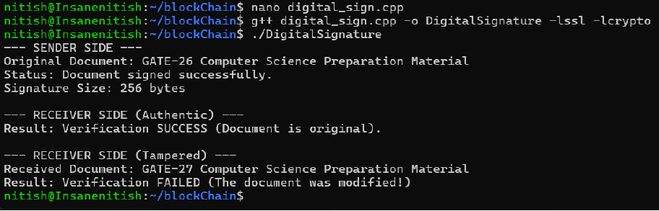

Practical 2: Blockchain Implementation with Transactions

Date | 12/04/2026
Language | C++ (STL)
Algorithm | std::hash (SHA-256 simulation)

Question
Create a functional blockchain structure. Each block must contain:
(a) A unique hash (using SHA-256 algorithm)
(b) A transaction history (list of sender, receiver, and amount)
(c) A timestamp indicating when the block was created
(d) The previous block's hash to maintain chain integrity

Code

#include <iostream>
#include <vector>
#include <string>
#include <ctime>
#include <functional>
#include <sstream>
using namespace std;

struct Transaction {
string sender, receiver;
double amount;
Transaction(string s, string r, double a) : sender(s), receiver(r), amount(a) {}
};

class Block {
private:
int index;
time_t timestamp;
vector<Transaction> transactions;
string previousHash;
string blockHash;

string calculateHash() const {
stringstream ss;
ss << index << timestamp << previousHash;
for (const auto& tx : transactions)
ss << tx.sender << tx.receiver << tx.amount;
hash<string> hasher;
return to_string(hasher(ss.str()));
}

public:
Block(int idx, vector<Transaction> txs, string prevHash) {
index = idx; transactions = txs; previousHash = prevHash;
timestamp = time(0); blockHash = calculateHash();
}
string getHash() const { return blockHash; }

void printBlock() const {
cout << "======================" << endl;
cout << "Block Index : " << index << endl;
cout << "Creation Time: " << ctime(&timestamp);
cout << "Previous Hash: " << previousHash << endl;
cout << "Block Hash : " << blockHash << endl;
cout << "--- Transactions ---" << endl;
if (transactions.empty()) cout << "Genesis Block" << endl;
for (const auto& tx : transactions)
cout << tx.sender << " -> " << tx.receiver << " : " << tx.amount << endl;
}
};

class Blockchain {
vector<Block> chain;
public:
Blockchain() { chain.push_back(Block(0, {}, "0")); }
void addBlock(vector<Transaction> txs) {
chain.push_back(Block(chain.size(), txs, chain.back().getHash()));
}
void printChain() const { for (const auto& b : chain) b.printBlock(); }
};

int main() {
Blockchain myCoin;
myCoin.addBlock({ {"nitish","modiji",50.0}, {"modiji","trump",20.5} });
myCoin.addBlock({ {"trump","nitish",10.0}, {"nitish","trump",100.0} });
myCoin.printChain();
return 0;
}

Output

Mining Block 1...
Mining Block 2...

Displaying Full Blockchain:

=======================================
Block Index : 0
Creation Time: Sun Apr 12 18:06:05 2026
Previous Hash: 0
Block Hash : 15493619433555077481
--- Transaction History ---
No transactions (Genesis Block)
=======================================

=======================================
Block Index : 1
Previous Hash: 15493619433555077481
Block Hash : 4997426173472653269
Sender: nitish | Receiver: modiji | Amount: 50
Sender: modiji | Receiver: trump | Amount: 20.5
=======================================

=======================================
Block Index : 2
Previous Hash: 4997426173472653269
Block Hash : 5172321277400337343
Sender: trump | Receiver: nitish | Amount: 10
Sender: nitish | Receiver: trump | Amount: 100
=======================================
[Output Screenshot: Blockchain Implementation Output Terminal
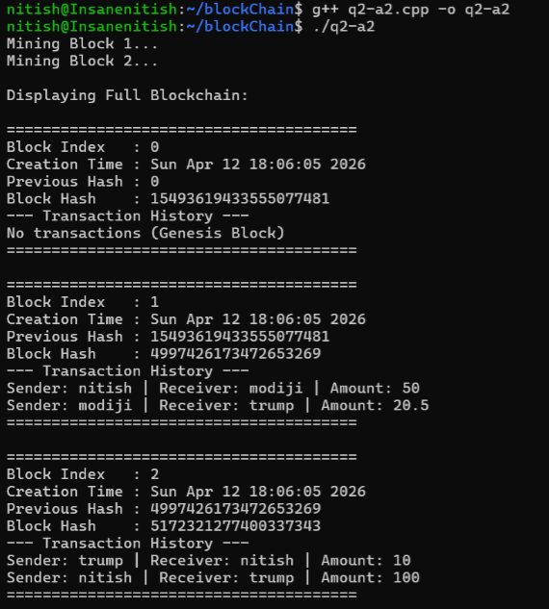

Practical 3: SHA-256 Hashing – Avalanche Effect

Date | 13/04/2026
Language | C++ (OpenSSL EVP API)
Concept | SHA-256, Avalanche Effect

Question
Q1: Implement a C++ program that generates SHA-256 hashes using the OpenSSL EVP API.
Q2: Compute the SHA-256 message digest for the string "Blockchain Developer" and display it.
Q3: Compare the SHA-256 hashes of "Hello World" and "Hello world". Explain the difference and the Avalanche Effect.

Code

#include <iostream>
#include <iomanip>
#include <sstream>
#include <string>
#include <openssl/evp.h>

std::string generateSHA256(const std::string& data) {
unsigned char hash[EVP_MAX_MD_SIZE];
unsigned int lengthOfHash = 0;
EVP_MD_CTX* context = EVP_MD_CTX_new();
if (context != nullptr) {
if (EVP_DigestInit_ex(context, EVP_sha256(), nullptr)) {
EVP_DigestUpdate(context, data.c_str(), data.size());
EVP_DigestFinal_ex(context, hash, &lengthOfHash);
}
EVP_MD_CTX_free(context);
}
std::stringstream ss;
for (unsigned int i = 0; i < lengthOfHash; i++)
ss << std::hex << std::setw(2) << std::setfill('0') << (int)hash[i];
return ss.str();
}

int main() {
// Q2
std::string str1 = "Blockchain Developer";
std::cout << "Q2 - Target String:\n" << str1 << "\n";
std::cout << "SHA-256 Digest:\n" << generateSHA256(str1) << "\n\n";

// Q3
std::string str2 = "Hello World";
std::string str3 = "Hello world";
std::cout << "Q3 - Case Sensitivity Comparison:\n";
std::cout << "SHA-256(\"Hello World\") = " << generateSHA256(str2) << "\n";
std::cout << "SHA-256(\"Hello world\") = " << generateSHA256(str3) << "\n";
return 0;
}

Output

Q2 - Target String:
Blockchain Developer
SHA-256 Digest:
0e3f62dab611686a781b2b9fd2a29544ed9829147b104cc4ad6315d88cde37e0

Q3 - Case Sensitivity Comparison:
SHA-256("Hello World") = a591a6d40bf420404a011733cfb7b190d62c65bf0bcda32b57b277d9ad9f146e
SHA-256("Hello world") = 64ec88ca00b268e5ba1a35678a1b5316d212f4f366b2477232534a8aeca37f3c

[Output Screenshot: SHA-256 Hashing Output Terminal]
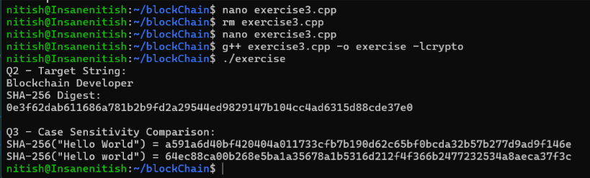

Explanation – Avalanche Effect
The hashes for "Hello World" and "Hello world" are completely different despite the input differing by only a single character (the case of 'W'). This is known as the Avalanche Effect: in a secure cryptographic hash function like SHA-256, even a single-bit change in the input results in a significantly different output digest. This property ensures high sensitivity to data integrity issues and prevents attackers from predicting output changes based on input modifications.

Practical 4: SHA-256 Hash for 'Hello World'

Date | 18/04/2026
Language | C++ (OpenSSL SHA.h)
Algorithm | SHA-256

Question
Implement a C++ program that generates a 256-bit SHA-256 hash for the string "Hello World". Demonstrate the ability to utilize cryptographic libraries to produce secure message digests, ensuring data integrity. Note that SHA-256 is a one-way function – it cannot be reversed or decrypted.

Code

#include <iostream>
#include <iomanip>
#include <sstream>
#include <string>
#include <openssl/sha.h>

std::string generate_sha256(const std::string& input) {
unsigned char hash[SHA256_DIGEST_LENGTH];
SHA256(reinterpret_cast<const unsigned char*>(input.c_str()),
input.length(), hash);
std::stringstream ss;
for (int i = 0; i < SHA256_DIGEST_LENGTH; i++)
ss << std::hex << std::setw(2) << std::setfill('0') << (int)hash[i];
return ss.str();
}

int main() {
std::string text = "Hello World";
std::cout << "Input String: " << text << "\n";
std::cout << "SHA-256 Hash: " << generate_sha256(text) << "\n";
return 0;
}

Compilation Command

g++ exe4.cpp -lcrypto -o exe4
./exe4

Output

Input String: Hello World
SHA-256 Hash: a591a6d40bf420404a011733cfb7b190d62c65bf0bcda32b57b277d9ad9f146e

[Output Screenshot: SHA-256 Hello World Output Terminal]

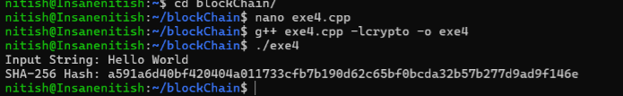

Technical Verification
The generated hash for "Hello World" exactly matches the expected cryptographic standard. SHA-256 is a one-way hashing function designed for integrity verification. Any minor modification to the input string, such as changing capitalization or adding a space, results in a completely different hash output due to the avalanche effect.

Practical 5: RSA Encryption & Decryption

Language | Python 3
Given Values | p=17, q=11, e=7, M=8
Algorithm | RSA (Rivest-Shamir-Adleman)

Question
Implement the RSA encryption and decryption algorithm from scratch in Python (without any external cryptography libraries). Given p=17, q=11, public exponent e=7, and message M=8, perform:
(a) Key Generation: Compute n, φ(n), and the private key d
(b) Encryption: Compute ciphertext C = M^e mod n
(c) Decryption: Recover M = C^d mod n
(d) Verification: Confirm the decrypted value equals the original message

Step-by-Step Mathematical Calculation

Step 1 – Primes: p = 17 (prime), q = 11 (prime)
Step 2 – Modulus: n = p x q = 17 x 11 = 187
Step 3 – Totient: phi(n) = (17-1)(11-1) = 16 x 10 = 160
Step 4 – Public e: e = 7 | gcd(7, 160) = 1 (coprime) ✓
Step 5 – Private d: 7 x d ≡ 1 (mod 160) => 7 x 23 = 161 = 160+1 ✓ d = 23
Step 6 – Keys: Public Key (e,n) = (7, 187) | Private Key (d,n) = (23, 187)
Step 7 – Encrypt: C = 8^7 mod 187 = 134
Step 8 – Decrypt: M = 134^23 mod 187 = 8 ✓

Code

import math

p = 17; q = 11; e = 7; M = 8

n = p * q
phi_n = (p - 1) * (q - 1)

assert 1 < e < phi_n and math.gcd(e, phi_n) == 1

d = None
for i in range(1, phi_n):
if (e * i) % phi_n == 1:
d = i
break

C = pow(M, e, n) # Encryption
M_dec = pow(C, d, n) # Decryption

print('=' * 50)
print('RSA Encryption & Decryption')
print('=' * 50)
print(f'Primes : p = {p}, q = {q}')
print(f'n = p x q : {p} x {q} = {n}')
print(f'phi(n) : ({p}-1)({q}-1) = {phi_n}')
print(f'Public Key : (e, n) = ({e}, {n})')
print(f'Private Key : (d, n) = ({d}, {n})')
print(f'Ciphertext : C = {M}^{e} mod {n} = {C}')
print(f'Decrypted : M = {C}^{d} mod {n} = {M_dec}')
if M_dec == M:
print(f'SUCCESS! Decrypted({M_dec}) == Original({M})')
print('=' * 50)

Output

==================================================
RSA Encryption & Decryption
==================================================
Primes : p = 17, q = 11
n = p x q : 17 x 11 = 187
phi(n) : (17-1)(11-1) = 160
Public Key : (e, n) = (7, 187)
Private Key : (d, n) = (23, 187)
Ciphertext : C = 8^7 mod 187 = 134
Decrypted : M = 134^23 mod 187 = 8
SUCCESS! Decrypted(8) == Original(8)
==================================================

[Output Screenshot: RSA Encryption Output Terminal]
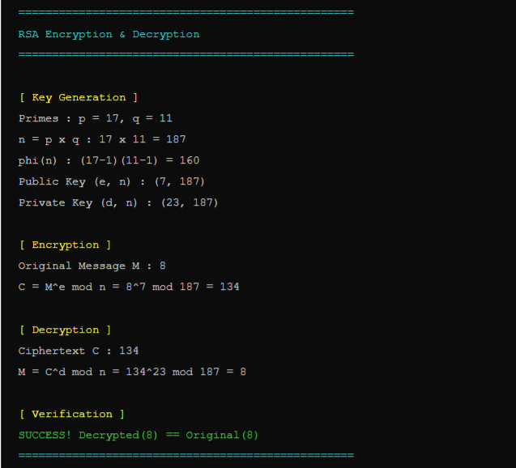

Practical 6: Proof of Work Blockchain

Date | 19/04/2026
Language | Python 3 (hashlib)
Concept | Proof of Work (PoW), Nonce, Mining

Question
Implement a basic blockchain system incorporating the Proof of Work (PoW) consensus mechanism. The system must:
(a) Mine each block by adjusting a nonce until the SHA-256 hash begins with prefix "00"
(b) Link blocks through cryptographic hashes (each block stores the previous block's hash)
(c) Display the index, data, previous hash, nonce, and final hash for each mined block

Code

import hashlib

class Block:
def __init__(self, index, data, previous_hash):
self.index = index
self.data = data
self.previous_hash = previous_hash
self.nonce = 0
self.hash = self.mine_block()

def calculate_hash(self):
content = str(self.index) + self.data + self.previous_hash + str(self.nonce)
return hashlib.sha256(content.encode()).hexdigest()

def mine_block(self):
prefix = "00"
while True:
hash_val = self.calculate_hash()
if hash_val.startswith(prefix):
return hash_val
self.nonce += 1

class Blockchain:
def __init__(self):
self.chain = []
self.create_genesis_block()

def create_genesis_block(self):
self.chain.append(Block(0, "Genesis Block", "0"))

def add_block(self, data):
prev_block = self.chain[-1]
self.chain.append(Block(len(self.chain), data, prev_block.hash))

def print_chain(self):
for block in self.chain:
print("\n==============================")
print("Index:", block.index)
print("Data:", block.data)
print("Previous Hash:", block.previous_hash)
print("Nonce:", block.nonce)
print("Hash:", block.hash)

if __name__ == "__main__":
blockchain = Blockchain()
blockchain.add_block("A -> B")
blockchain.add_block("B -> C")
blockchain.add_block("C -> D")
blockchain.print_chain()

Output

==============================
Index: 0
Data: Genesis Block
Previous Hash: 0
Nonce: 642
Hash: 00fdcb7606e2fd2a721926e16edbfca1cd83b534e9352aa144eb28ac1819fa54

==============================
Index: 1
Data: A -> B
Previous Hash: 00fdcb7606e2fd2a721926e16edbfca1cd83b534e9352aa144eb28ac1819fa54
Nonce: 68
Hash: 00f2a803049746798e144fe4230326e517b7483436c4ef13a4354c14f54539b1

==============================
Index: 2
Data: B -> C
Previous Hash: 00f2a803049746798e144fe4230326e517b7483436c4ef13a4354c14f54539b1
Nonce: 291
Hash: 0070c3fd4eac420c36bc6559654bdfb27ec13dadad26b41e8402b900bc9384da

==============================
Index: 3
Data: C -> D
Previous Hash: 0070c3fd4eac420c36bc6559654bdfb27ec13dadad26b41e8402b900bc9384da
Nonce: 403
Hash: 00108190c02e08c6c16bfde55d6cd98d36f261aeff9c0e1dac57c311daa8d8bd

[Output Screenshot: Proof of Work Blockchain Output Terminal]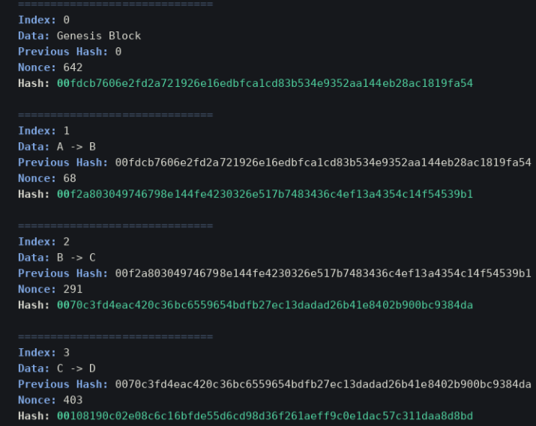

Practical 7: 5-Block Blockchain, Tamper Detection & Distributed Network

Language | Python 3 (hashlib, json)
Concepts | Chain Integrity, Tampering, Distributed Nodes

Q1 – Blockchain of 5 Blocks with SHA-256 Hash & Integrity Check
Question: Create a blockchain of 5 blocks, print the SHA-256 hash of each block, and verify chain integrity.

import hashlib, json, time

class Block:
def __init__(self, index, data, previous_hash):
self.index = index
self.timestamp = time.time()
self.data = data
self.previous_hash = previous_hash
self.hash = self.compute_hash()

def compute_hash(self):
content = json.dumps({
"index": self.index, "timestamp": self.timestamp,
"data": self.data, "previous_hash": self.previous_hash
}, sort_keys=True)
return hashlib.sha256(content.encode()).hexdigest()

class Blockchain:
def __init__(self):
self.chain = [self._genesis()]

def _genesis(self):
return Block(0, "Genesis Block - Nitish", "0" * 64)

def add_block(self, data):
last = self.chain[-1]
self.chain.append(Block(len(self.chain), data, last.hash))

def verify(self):
for i in range(1, len(self.chain)):
b, p = self.chain[i], self.chain[i-1]
if b.hash != b.compute_hash() or b.previous_hash != p.hash:
return False
return True

bc = Blockchain()
bc.add_block("Nitish sends 100 coins to Arjun")
bc.add_block("Arjun sends 40 coins to Sneha")
bc.add_block("Sneha sends 25 coins to Nitish")
bc.add_block("Nitish sends 60 coins to Vikram")

for b in bc.chain:
print(f"Block {b.index}: {b.hash}")
print(f"\nChain Valid: {bc.verify()}")

Q1 Output

Block 0: 92153775ca177bbb9b0b74e7985b566c19f12b3035d71c13d4b2dd557b0855a4
Block 1: abded406340b737739da737c5e26584ee232fb87f3b5ddbecb732ad3d20efe26
Block 2: 861b64f0334a6b80308c26610b1b472a7ebb1e25cb13741b857237626c65e0c4
Block 3: 21600b967c0775212b8b61911a8e08caf3a8a5537f1a0137891476d0ce01035f
Block 4: 2f44dc104c241d00e77d1fb26a71ecd67da6594915458188f10a21e6989edd4d

Chain Valid: True

[Output Screenshot: Blockchain 5 Blocks Output]
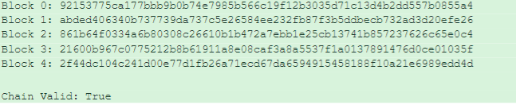

Q2 – Tamper Block 3 and Detect Chain Validation Failure
Question: Tamper with the 3rd block (index 2) and show how validation detects the breach.

# Tamper with Block 2
print("\n--- Tampering with Block 2 ---")
original = bc.chain[2].data
print(f"Original data : {original}")
bc.chain[2].data = "HACKED: Arjun sends 500 coins to Nitish"
print(f"Tampered data : {bc.chain[2].data}")
print(f"Stale hash : {bc.chain[2].hash}")
print(f"Actual hash : {bc.chain[2].compute_hash()}")
print(f"\nChain Valid: {bc.verify()}")
for i in range(1, len(bc.chain)):
if bc.chain[i].previous_hash != bc.chain[i-1].hash:
print(f" [!] CHAIN INTEGRITY BROKEN at Block {i}")

Q2 Output
--- Tampering with Block 2 ---
Original data : Arjun sends 40 coins to Sneha
Tampered data : HACKED: Arjun sends 500 coins to Nitish
Stale hash : 861b64f0334a6b80308c26610b1b472a7ebb1e25cb13741b857237626c65e0c4
Actual hash : 0286ad5bc2cc8fbcb6e4b74a1158d5a2dc23e3c2ef5c6baee62d8ce688f83fa6

Chain Valid: False
[!] CHAIN INTEGRITY BROKEN at Block 3
[Output Screenshot: Tamper Detection Output]
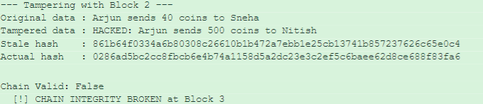

Q3 – 5-Node Distributed Network
Question: Create a blockchain network with 5 nodes and check validity across each node.

import copy

class Node:
def __init__(self, node_id, chain=None):
self.node_id = node_id
self.blockchain = copy.deepcopy(chain) if chain else Blockchain()

def is_valid(self):
return self.blockchain.verify()

master = Blockchain()
master.add_block("Node1 -> Node2: Transfer 10 BTC")
master.add_block("Node2 -> Node3: Transfer 5 BTC")
master.add_block("Node3 -> Node4: Transfer 3 BTC")
master.add_block("Node4 -> Node5: Transfer 2 BTC")

nodes = [Node(i+1, master) for i in range(5)]
for node in nodes:
print(f"Node {node.node_id} Valid: {node.is_valid()}")
for b in node.blockchain.chain:
print(f" Block {b.index}: {b.hash[:20]}...")

Q3 Output

Node 1 Valid: True
Block 0: 26b68c87a806f0f458...
Block 1: 06d11310b8c2394720...
Block 2: 3bef3b2ac45a24d8db...
Block 3: a555e2c8fdef04ab95...
Block 4: 66540c6f7f5022a4a6...
...
Node 5 Valid: True

Node Network Valid: True
All 5 nodes hold identical, valid blockchain.

[Output Screenshot: Distributed 5-Node Network Output]
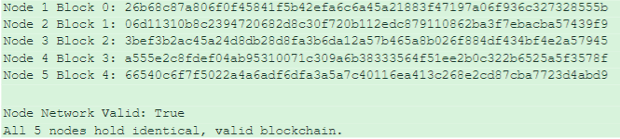

Practical 8: Solidity Smart Contract Implementation

Language | Solidity ^0.8.0
Platform | Remix IDE (Ethereum VM)
Concepts | Smart Contracts, Mappings, Fund Transfer

Q1 – Basic Smart Contract Structure (Student Registry)
Question: Implement a Solidity smart contract to store and retrieve student data (name and age) on the Ethereum blockchain. Include functions to register a student, get student details, and return the total number of registered students.

// SPDX-License-Identifier: MIT
pragma solidity ^0.8.0;

contract StudentRegistry {
struct Student {
string name;
uint age;
}

mapping(address => Student) public students;
address[] public studentAddresses;

function registerStudent(string memory _name, uint _age) public {
require(bytes(_name).length > 0, "Name cannot be empty");
require(_age > 0, "Age must be greater than 0");
students[msg.sender] = Student(_name, _age);
studentAddresses.push(msg.sender);
}

function getStudent(address _studentAddress)
public view returns (string memory, uint) {
Student memory student = students[_studentAddress];
return (student.name, student.age);
}

function getTotalStudents() public view returns (uint) {
return studentAddresses.length;
}
}

Q1 Output
Deployed to Remix EVM. After calling registerStudent("Nitish Thakur", 21) and then getStudent(address):

decoded output: {
"0": "string: Nitish Thakur",
"1": "uint256: 21"
}
status: 0x1 Transaction mined and execution succeed

[Output Screenshot: StudentRegistry Remix IDE Screenshot]
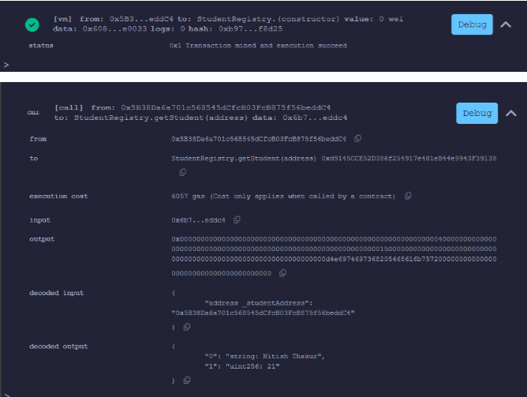

Q3 – Fund Transfer Contract
Question: Develop a Solidity mechanism for peer-to-peer Ether fund transfers between users on the blockchain. Include deposit, transfer, and balance query functions.

// SPDX-License-Identifier: MIT
pragma solidity ^0.8.0;

contract FundTransfer {
mapping(address => uint) public balances;

function deposit() public payable {
balances[msg.sender] += msg.value;
}

function transfer(address _to, uint _amount) public {
require(balances[msg.sender] >= _amount, "Insufficient balance");
balances[msg.sender] -= _amount;
balances[_to] += _amount;
}

function getBalance(address _user) public view returns (uint) {
return balances[_user];
}
}

Q3 Output
[Output Screenshot: FundTransfer Remix IDE Deploy & Run Screenshot]
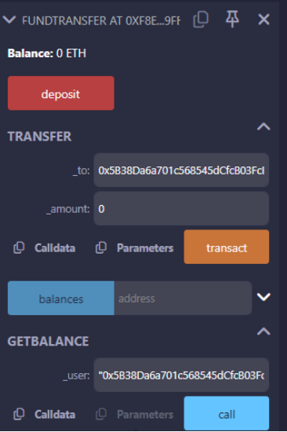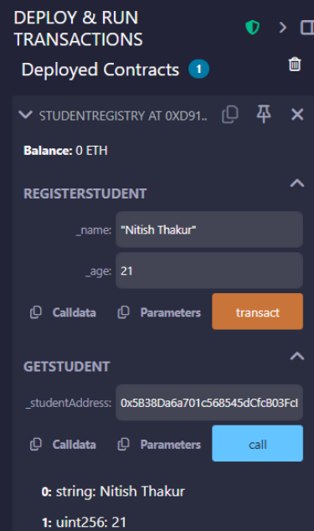

Practical 9: Hyperledger Fabric – Setup & Execution

Date | 27/04/2026
Platform | Hyperledger Fabric (Docker)
Chaincode | Go (asset-transfer-basic)

Objective
Create and deploy a permissioned blockchain network using Hyperledger Fabric. Execute transactions and demonstrate secure communication between multiple organizations (Org1 and Org2) within the network.

Exercise 1: Network Initialization
Question: Initialize a Hyperledger Fabric test network using Docker containers and verify all core nodes are running.

# Step 1: Navigate to test-network directory
cd fabric-samples/test-network

# Step 2: Start the network (brings up peers and orderer)
./network.sh up

# Step 3: Verify active Docker containers
docker ps

Output – Active Containers

peer0.org1.example.com -- Up
peer0.org2.example.com -- Up
orderer.example.com -- Up

[Output Screenshot: Docker PS Output – Active Fabric Containers]
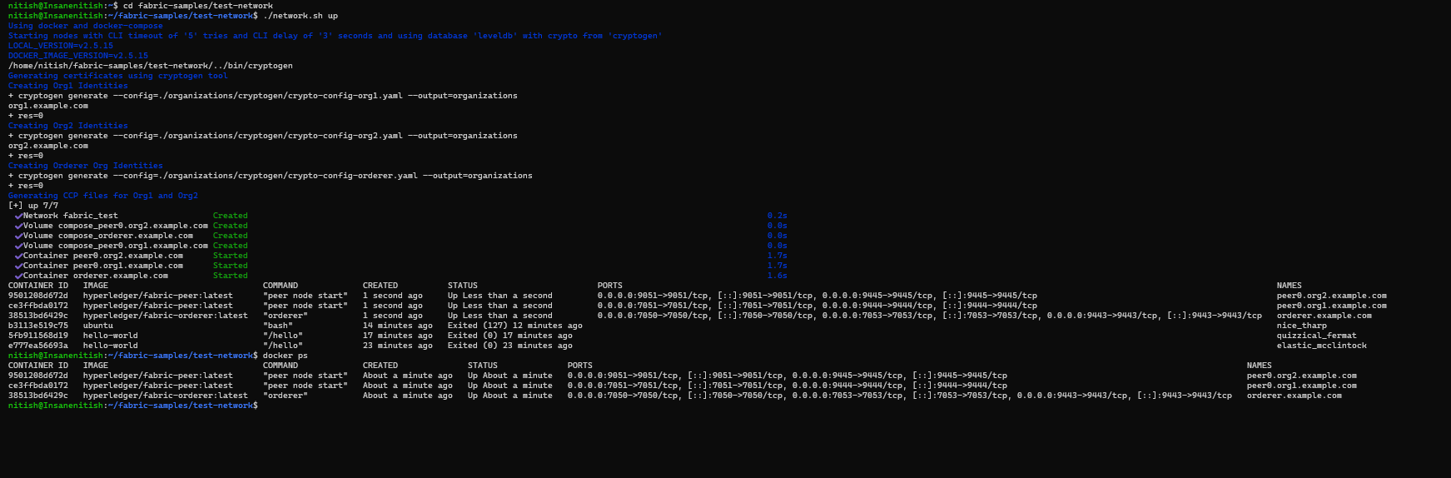

Exercise 2: Permissioned Ledger & Transaction Execution
Question: Create a channel, deploy chaincode, create an asset, and query it from the ledger.

# Step 1: Create channel 'mychannel'
./network.sh createChannel

# Step 2: Deploy the basic asset-transfer chaincode (Go)
./network.sh deployCC -ccn basic -ccp ../asset-transfer-basic/chaincode-go -ccl go

# Step 3: Set environment for Org1
export CORE_PEER_LOCALMSPID="Org1MSP"
export CORE_PEER_TLS_ROOTCERT_FILE=$PWD/organizations/peerOrganizations/org1.example.com/peers/peer0.org1.example.com/tls/ca.crt
export CORE_PEER_MSPCONFIGPATH=$PWD/organizations/peerOrganizations/org1.example.com/users/Admin@org1.example.com/msp
export CORE_PEER_ADDRESS=localhost:7051

# Step 4: Create asset on the ledger
peer chaincode invoke ... \
-c '{"function":"CreateAsset","Args":["assetNitish1","black","7","Nitish","999"]}'

# Step 5: Query the asset
peer chaincode query -C mychannel -n basic \
-c '{"Args":["ReadAsset","assetNitish1"]}'

Output – Ledger Query Result

{
"ID": "assetNitish1",
"Color": "black",
"Size": 7,
"Owner": "Nitish",
"AppraisedValue": 999
}

[Output Screenshot: 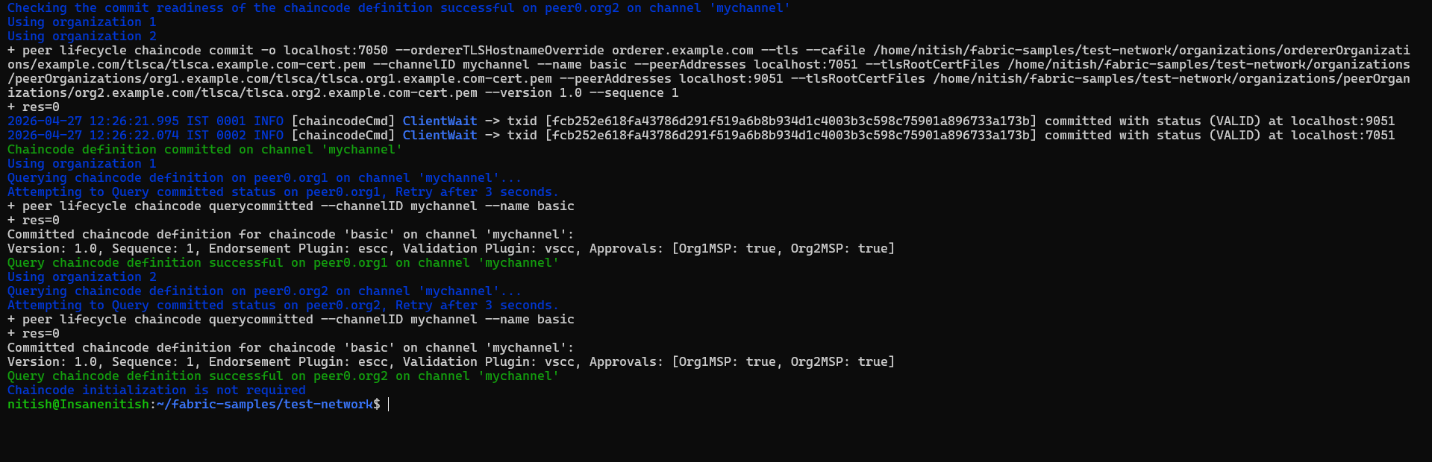 Chaincode Deployment & Asset Creation Terminal] 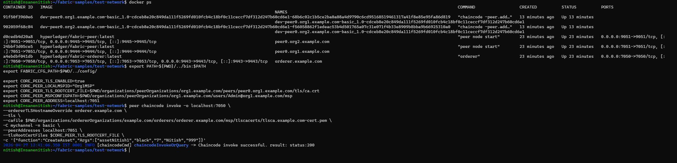

Exercise 3: Cross-Organization Communication
Question: Validate that Organization 2 can read an asset originally created by Organization 1, proving the distributed shared ledger.

# Switch to Org2 context (port 9051)
export CORE_PEER_LOCALMSPID="Org2MSP"
export CORE_PEER_TLS_ROOTCERT_FILE=$PWD/organizations/peerOrganizations/org2.example.com/peers/peer0.org2.example.com/tls/ca.crt
export CORE_PEER_MSPCONFIGPATH=$PWD/organizations/peerOrganizations/org2.example.com/users/Admin@org2.example.com/msp
export CORE_PEER_ADDRESS=localhost:9051

# Org2 queries the asset created by Org1
peer chaincode query -C mychannel -n basic \
-c '{"Args":["ReadAsset","assetNitish1"]}'

Output

{"AppraisedValue":999,"Color":"black","ID":"assetNitish1","Owner":"Nitish","Size":7}

[Output Screenshot: Org2 Cross-Org Query Output Terminal]
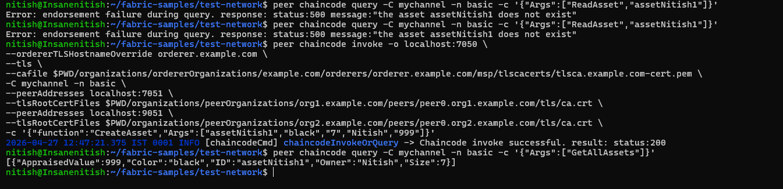

Key Learnings
- Permissioned Access: Fabric restricts ledger access to authorized participants only.
- Chaincode Logic: Business rules are strictly enforced through smart contracts.
- Channels: Provide private communication paths between specific network members.
- Distributed Ledger: All participating organizations maintain a consistent state of the truth.

